Oblique Quadrilateral Pyramid
# Source: AI Source: Provided by: [Data Path: Persons Table -> ID Column: 1, Name_En Column: Motasem Essam] -> From: [ChatGPT] on [7/25/2026]
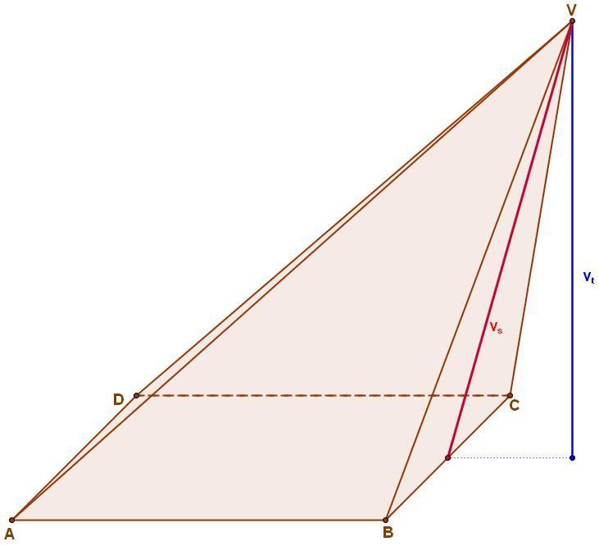
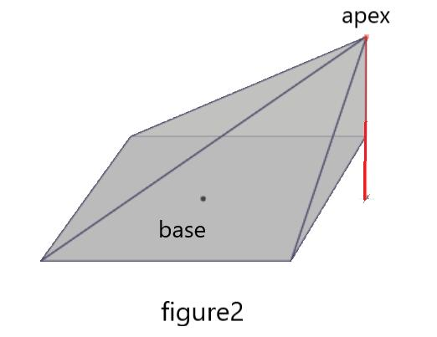
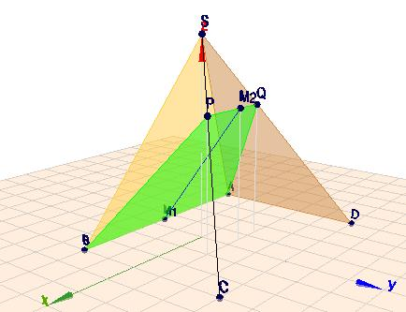

Definition
# Source: AI Source: Provided by: [Data Path: Persons Table -> ID Column: 1, Name_En Column: Motasem Essam] -> From: [ChatGPT] on [7/25/2026]
An oblique quadrilateral pyramid is a three-dimensional geometric solid with a quadrilateral base and an apex positioned away from the designated center of the base, so that the perpendicular from the apex to the base plane does not meet that center.
The base may be a square, rectangle, rhombus, parallelogram, or trapezoid. Unlike a right quadrilateral pyramid, an oblique quadrilateral pyramid has a slanted orientation relative to its base.
An oblique quadrilateral pyramid has:
- 1 quadrilateral base.
- 4 triangular lateral faces.
- 5 faces in total.
- 8 edges in total.
- 5 vertices in total.
Its triangular lateral faces generally have different shapes and areas. The perpendicular height is measured from the apex to the base plane, even if the point where it meets the plane lies outside the base polygon.

Simple Definition
# Source: AI Source: Provided by: [Data Path: Persons Table -> ID Column: 1, Name_En Column: Motasem Essam] -> From: [ChatGPT] on [7/25/2026]
An oblique quadrilateral pyramid is a pyramid with a four-sided base whose apex is not directly above the designated center of the base.

Key Characteristics
# Source: AI Source: Provided by: [Data Path: Persons Table -> ID Column: 1, Name_En Column: Motasem Essam] -> From: [ChatGPT] on [7/25/2026]
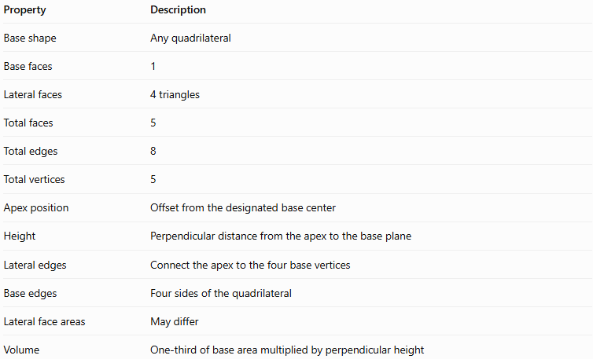
Property | Description
Base shape | Any quadrilateral
Base faces | 1
Lateral faces | 4 triangles
Total faces | 5
Total edges | 8
Total vertices | 5
Apex position | Offset from the designated base center
Height | Perpendicular distance from the apex to the base plane
Lateral edges | Connect the apex to the four base vertices
Base edges | Four sides of the quadrilateral
Lateral face areas | May differ
Volume | One-third of base area multiplied by perpendicular height

Geometric Representation
# Source: AI Source: Provided by: [Data Path: Persons Table -> ID Column: 1, Name_En Column: Motasem Essam] -> From: [ChatGPT] on [7/25/2026]
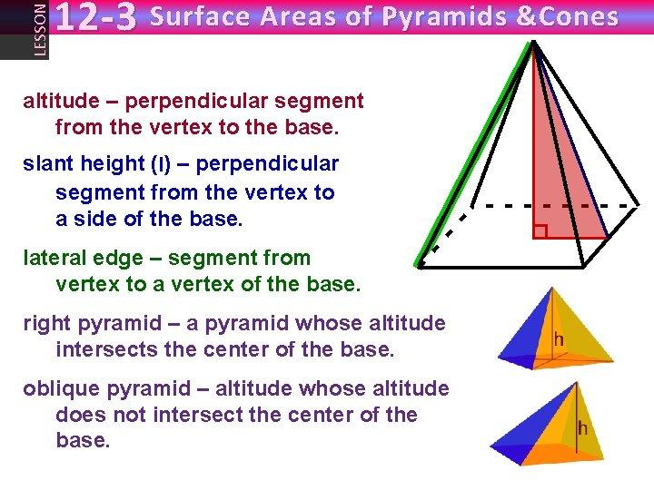
The main components are:
- Base: The quadrilateral forming the bottom face.
- Apex: The vertex that does not lie directly above the designated center of the base.
- Base edges: The four sides of the quadrilateral.
- Lateral edges: The four slanted line segments joining the apex to the base vertices.
- Lateral faces: Four triangular surfaces connecting the apex to the base edges.
- Height: The perpendicular distance from the apex to the plane of the base.
- Slant height of a face: The perpendicular altitude of an individual triangular lateral face.
The perpendicular height and the slant height are different measurements. A lateral edge is also generally different in length from the perpendicular height.

Mathematical Representations and Formulas
# Source: AI Source: Provided by: [Data Path: Persons Table -> ID Column: 1, Name_En Column: Motasem Essam] -> From: [ChatGPT] on [7/25/2026]
Let:
- $B$ = area of the quadrilateral base.
- $P$ = perimeter of the base.
- $H$ = perpendicular height of the pyramid.
- $A_{L}$ = lateral surface area.
- $A_{T}$ = total surface area.

Base Area
# Source: AI Source: Provided by: [Data Path: Persons Table -> ID Column: 1, Name_En Column: Motasem Essam] -> From: [ChatGPT] on [7/25/2026]
The base area depends on the type of quadrilateral.
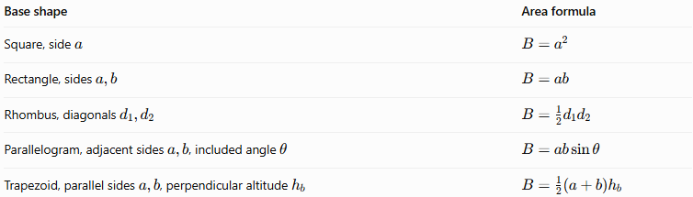
Base shape | Area formula
Square, side $a$ | $$B=a^{2}$$
Rectangle, sides $a,b$ | $$B=ab$$
Rhombus, diagonals $d_{1},d_{2}$ | $$B=\frac{1}{2}d_{1}d_{2}$$
Parallelogram, adjacent sides $a,b$, included angle $θ$ | $$B=ab\sin{θ}$$
Trapezoid, parallel sides $a,b$, perpendicular altitude $h_{b}$ | $$B=\frac{1}{2}\left(a+b\right)h_{b}$$

Volume
# Source: AI Source: Provided by: [Data Path: Persons Table -> ID Column: 1, Name_En Column: Motasem Essam] -> From: [ChatGPT] on [7/25/2026]
The volume of an oblique pyramid is calculated using the same formula as a right pyramid:
$$\boxed{V=\frac{1}{3}BH}$$
The height $H$ must be the perpendicular distance from the apex to the plane containing the base, not the length of a slanted edge.

Lateral Surface Area
# Source: AI Source: Provided by: [Data Path: Persons Table -> ID Column: 1, Name_En Column: Motasem Essam] -> From: [ChatGPT] on [7/25/2026]
The lateral surface area is the sum of the areas of the four triangular faces:
$$\boxed{A_{L}=A_{1}+A_{2}+A_{3}+A_{4}}$$
For each triangular face:
$$A_{i}=\frac{1}{2}s_{i}l_{i}$$
where:
- $s_{i}$ is the corresponding base-edge length.
- $l_{i}$ is the perpendicular altitude of that triangular face.
Therefore:
$$\boxed{A_{L}=\frac{1}{2}\sum_{i=1}^{4}{s_{i}}l_{i}}$$
For an oblique pyramid, the four slant heights $l_{i}$ are generally different. Consequently, the simplified formula
$$A_{L}=\frac{1}{2}Pl$$
cannot generally be used unless a common slant height is valid for all faces.

Total Surface Area
# Source: AI Source: Provided by: [Data Path: Persons Table -> ID Column: 1, Name_En Column: Motasem Essam] -> From: [ChatGPT] on [7/25/2026]
The total surface area includes the base and the four lateral faces:
$$\boxed{A_{T}=B+A_{L}}$$

Euler’s Formula
# Source: AI Source: Provided by: [Data Path: Persons Table -> ID Column: 1, Name_En Column: Motasem Essam] -> From: [ChatGPT] on [7/25/2026]
Every convex quadrilateral pyramid satisfies Euler’s formula:
$$V_{e}-E+F=2$$
Substituting the counts:
$$5-8+5=2$$
Here, $V_{e}$ represents the number of vertices, not volume.

Worked Examples
# Source: AI Source: Provided by: [Data Path: Persons Table -> ID Column: 1, Name_En Column: Motasem Essam] -> From: [ChatGPT] on [7/25/2026]
Example 1: Finding the Volume
An oblique quadrilateral pyramid has a rectangular base measuring $8\text{ cm}$ by $5\text{ cm}$. Its perpendicular height is $9\text{ cm}$. Find its volume.
First, calculate the base area:
$$B=8×5=40{\text{ cm}}^{2}$$
Then calculate the volume:
$$V=\frac{1}{3}BH$$
$$V=\frac{1}{3}\left(40\right)\left(9\right)$$
$$\boxed{V=120{\text{ cm}}^{3}}$$
The apex's offset position does not change the volume formula.
Example 2: Finding the Base Area
A rhombus-base oblique pyramid has base diagonals of $10\text{ cm}$ and $6\text{ cm}$. Find its base area.
$$B=\frac{1}{2}d_{1}d_{2}$$
$$B=\frac{1}{2}\left(10\right)\left(6\right)$$
$$\boxed{B=30{\text{ cm}}^{2}}$$
Example 3: Finding the Total Surface Area
An oblique quadrilateral pyramid has a base area of $30{\text{ cm}}^{2}$. Its four triangular faces have areas of $12{\text{ cm}}^{2}$, $15{\text{ cm}}^{2}$, $18{\text{ cm}}^{2}$, and $20{\text{ cm}}^{2}$. Find its total surface area.
First, add the four lateral face areas:
$$A_{L}=12+15+18+20$$
$$A_{L}=65{\text{ cm}}^{2}$$
Then add the base area:
$$A_{T}=B+A_{L}$$
$$A_{T}=30+65$$
$$\boxed{A_{T}=95{\text{ cm}}^{2}}$$
Example 4: Counting Faces, Edges, and Vertices
For a pyramid with a four-sided base, $n=4$.
$$F=n+1, E=2n, V_{e}=n+1$$
Therefore:
$$F=5, E=8, V_{e}=5$$
Answer: 5 faces, 8 edges, and 5 vertices.

Comparison with Related Pyramids
# Source: AI Source: Provided by: [Data Path: Persons Table -> ID Column: 1, Name_En Column: Motasem Essam] -> From: [ChatGPT] on [7/25/2026]
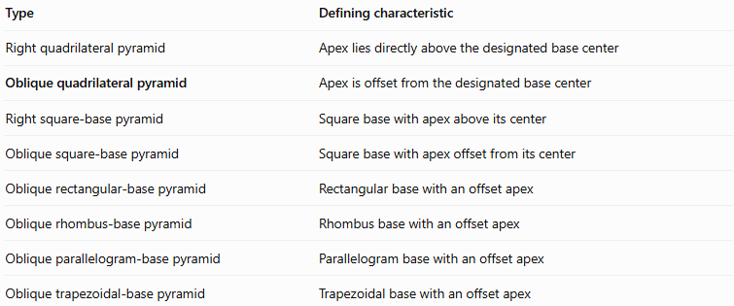
Type | Defining characteristic
Right quadrilateral pyramid | Apex lies directly above the designated base center
Oblique quadrilateral pyramid | Apex is offset from the designated base center
Right square-base pyramid | Square base with apex above its center
Oblique square-base pyramid | Square base with apex offset from its center
Oblique rectangular-base pyramid | Rectangular base with an offset apex
Oblique rhombus-base pyramid | Rhombus base with an offset apex
Oblique parallelogram-base pyramid | Parallelogram base with an offset apex
Oblique trapezoidal-base pyramid | Trapezoidal base with an offset apex
A pyramid can be classified in two ways at once: by its base shape and by its spatial orientation. For example, an oblique square-base pyramid belongs to both the square-base-pyramid category and the oblique-pyramid category.

Applications
# Source: AI Source: Provided by: [Data Path: Persons Table -> ID Column: 1, Name_En Column: Motasem Essam] -> From: [ChatGPT] on [7/25/2026]
Oblique quadrilateral pyramids are useful in:
- Architecture: Designing asymmetrical roofs, artistic structures, and sloping architectural forms.
- Engineering: Modeling tapered components with offset centers.
- 3D modeling: Creating geometric solids with noncentral apex positions.
- Geometry education: Comparing perpendicular height, lateral edges, and slant heights.
- Surface-area calculations: Demonstrating why the areas of individual triangular faces may need to be calculated separately.

Key Points
# Source: AI Source: Provided by: [Data Path: Persons Table -> ID Column: 1, Name_En Column: Motasem Essam] -> From: [ChatGPT] on [7/25/2026]
- An oblique quadrilateral pyramid has a quadrilateral base and four triangular lateral faces.
- It has 5 faces, 8 edges, and 5 vertices.
- Its apex is not directly above the designated center of the base.
- Its perpendicular height is measured to the base plane.
- Its volume is $V=\frac{1}{3}BH$.
- Its lateral surface area is the sum of its four triangular face areas.
- The four lateral faces may have different areas and slant heights.
- The formula $A_{L}=\frac{1}{2}Pl$ is not generally valid for an oblique quadrilateral pyramid.
- It may have a square, rectangle, rhombus, parallelogram, or trapezoid as its base.

Conclusion
# Source: AI Source: Provided by: [Data Path: Persons Table -> ID Column: 1, Name_En Column: Motasem Essam] -> From: [ChatGPT] on [7/25/2026]
An oblique quadrilateral pyramid is a three-dimensional polyhedron with a four-sided base and an apex that is offset from the designated center of the base. Its slanted orientation distinguishes it from a right quadrilateral pyramid, but both types have five faces, eight edges, and five vertices.
The volume is calculated using one-third of the base area multiplied by the perpendicular height. The surface area requires adding the areas of the base and the four triangular lateral faces. Because the apex is offset, the triangular faces generally differ in shape or area, making individual face calculations especially important.

